|  |
| --- |
| **Software Design Specifications**  **One Tap App** |

**Table of Contents**

**1** **Introduction 3**

*1.1* *Purpose of Document 3*

*1.2* *Scope 3*

**2** **Design Considerations 3**

*2.1* *Assumptions and Dependencies 3*

*2.2* *Scalability 3*

**3** **System Architecture 3**

*3.1* *Software Architecture 4*

**4** **Design Strategy 4**

**5** **Sequence Diagram 4**

* **Introduction**
* ***Purpose of Document***

The purpose of this document is to provide a brief overview about the *Design* of the problem that how we can *Book a Ride* in a single tap without any hustle to *install* the app, *login or signup*.

* ***Scope***

The system would be a *Web App* which would focus on providing a better user experience to book a ride on the go without any login/signup credentials.

* **Design Considerations**
* ***Assumptions and Dependencies***

For the time being, we are assuming that the current location would be the pickup location of the user. The system would be dependent on the API Responses generated by *Careem API.*

* ***Scalability***

Load balancing is one of the approaches to increase the number of concurrent client connections to the application server. This can be done by adding some backup servers in pipeline in rush hours.

* **System Architecture**

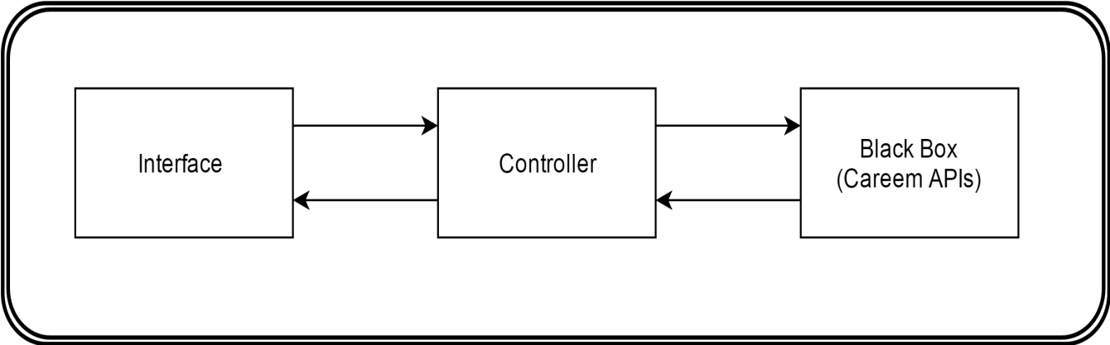

* **Design Strategy**

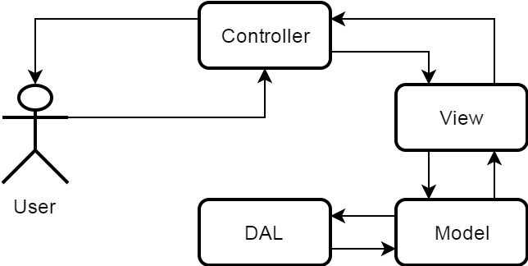

* ***Sequence Diagram***

